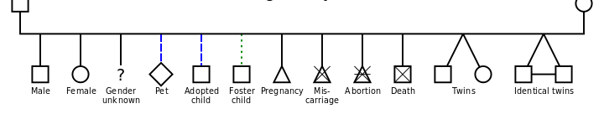
Genogram symbols

These can be colour coded to show strength in relationship i.e.
Blue = strong / positive relationship,
Red = stressful relationship
Green = weak / tenuous relationship

Eco Map symbols
