Return Home
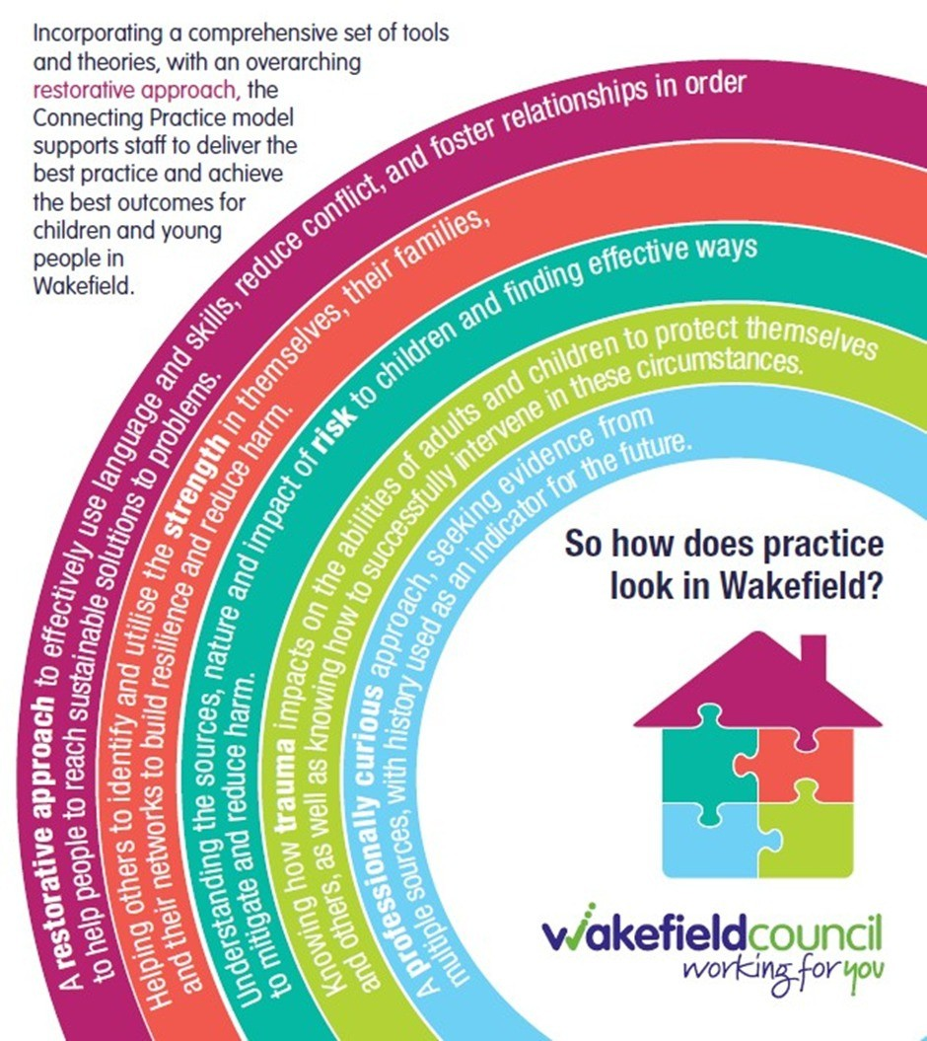
Interviews

Is your practice up to standard?

The purpose of the interview is to gather information about the child’s life with a holistic perspective to identify reasons for running or going missing. The interview is an opportunity for children to speak to an independent professional who can provide appropriate follow up with referrals or signposting
A good Return Home Interview can help understand and address the reasons why a child has run away; it can identify harm; help the child feel safe; provide them with information on how to stay safe; and allow professionals to identify actions to help them

The initial contact with the child will create the opportunity for a successful interview. If you are making contact by phone you have a very short amount of time to engage the child – they need to understand all that you are saying (no jargon), who you are and why you are calling and they need to hear that you are friendly, trustworthy and fair. If they don’t engage from the phone call, a letter can allow you to clearly explain to the young person why they should talk to you, so they have time to digest the information before you call them

Discuss Confidentially at the Beginning
Make sure they understand what information will need to be shared with other services and what information will always be kept confidential. When discussing consent, limits to confidentiality and safeguarding it is best practice to make some of the following considerations prior to the interview:

How will the information be used?

Will this information be shared directly with professionals already involved with the child?

Does the child understand and consent with full knowledge of the limitations of confidentiality?

The child must feel safe and comfortable with the interviewer to be able to share difficult information with them

Arrange to Hold the Interview in a Neutral Place
where the child feels safe, if possible. If you have to conduct the interview at home, it is important that you speak to the young person alone, but also make sure you give parents or carers space to talk about their concerns.

Turn up on Time
you said you cared when you phoned – but don’t be surprised if they have forgotten they are meeting you or don’t want to talk to you now. Your conversation needs to be caring, creative, conversational and courageous to develop a sharing culture and relationship - use child friendly discussion techniques.

Be Friendly and Listen
to how they want to proceed. It is important to ensure that they feel they can talk to you in the future; some young people run away frequently and may be referred to your service again.

Have a Problem Free Conversation With Them First
before you start taking notes - you need to form a trusting relationship.

Try to Identify the Reasons the Child Gives for Going Missing or Running Away
Was this the first time the child went missing or has it happened before?
Did the child go alone or with others? Were they persuaded to go by someone else?
Did they try to resolve the problem before it caused them to run away and if so, why didn’t this work?
Does the problem/trigger still exist?

Where Did the Child Go or Stay?
how did they get access to food, money, transport, clothing, etc? Did they get involved in criminal activity? Did they seek or need medical help?

Did They Get Help From Anyone?
how did they get access to food, money, transport, clothing, etc? Did they get involved in criminal activity? Did they seek or need medical help?

How Did They Feel?
did they feel physically and mentally healthy? Did they feel bullied or pressured? Were there signs of stress, depression or self-harm? Were they involved in substance misuse? What lead them to return or be found? How did they feel about returning.

A return interview is only effective if appropriate follow up support is offered to the young person to help them deal with the issues that caused them to run away or they experienced while they ran away

What Next?
Do the things that caused the child to go missing still exist?
What does the child see as the risk involved with running away again? What alternatives to running away might there be?
What does the child think might be done to prevent them from running away again?

Potential Push Factors to Look Out For:
Problems at home – ranging from arguments with parents to longer term abuse or maltreatment.
Family break up – young people drawn into their parents’ conflicts are less likely to do well at school and more likely to truant or run away from home.
Mental Health problems – a disproportionate number of young people who run away from home have mental health problems.
Bullying – children who are being severely bullied are more likely to run away from home or care.
Teenage pregnancy – some young women run away because they have become or fear they may be pregnant.
Emotional health – children who are struggling with their self-esteem, emotional well-being or sexual identity are more likely to run away from home or care.

Potential Pull Factors to Look Out For:
Running to be with or near friends or family – especially when a child is in care and there are problems with contact arrangements with family and friends.
Grooming for potential child exploitation or child trafficking –children do not usually recognise they are being groomed but respond to the initial affection or perceived kindness of an adult who is seeking to exploit them. They may see that adult as one who has promised to ‘look after’ them.

Put a Plan in Place to Address my Issues Identified During the Return Interview
always tell the child what you plan to do with what they have told you.

Assess
whether they might run away again and identify any immediate or long-term follow-up support such as counselling or a police referral.

Tell Them What You Will Do?
and agree what you will feed back to professionals, or their parents/ carers, if it isn’t a safeguarding concern.

Confidentiality
if a young person has disclosed something, they need to be reminded that you will pass this on if it is a concern. Do not break confidentiality without agreement. Talk through any consequences of sharing information with you and get agreement.

Your aim is to ensure that action by the relevant agencies is taken to reduce the risks the young person faces when running away and that intelligence is passed on

Be Clear to the Young Person About the Limitations of Your Support From Now On
while also being clear on how they can reach you if they need to.
Recording information Information shared by the young person in a return interview should be collected onto the Childs record on Liquid Logic. E.g where they were, who they were with and what happened while they were away (see template below).
The information given by the child must be shared with the social worker or lead professional at the earliest opportunity, along with any plan you have made with the child for follow on support or referrals to other agencies such as Early Intervention Services/ Youth Hubs Etc
Let the Missing/ CVE Police Team alongside the Child Vulnerable to Exploitation Team know of any ‘hot spots’, areas where children are going missing to, and individuals who target children for sexual exploitation. This evidence can help the police with their investigations and targeted services to be aimed at problem areas.

Resources:
Statutory guidance on children who run away or go missing from home or
care, Department for Education (2014).
Wakefield Operating Guidance for Children Missing from Home and Care . Joint Protocol for Children Missing from Home or Care
Working together to Safeguard Children 2018 / Revised Government consultation document 2023
The value of Return Home Interviews and follow-up support when young people go missing, Railway Children 2015

